NEDSS Training Exercises for
Module 4: Patient, Case Info, & TB History Tabs

Overview:
- This module contains 3 exercises, #4-6.
- When you have finished, email your supervisor your responses.
Instructions
Exercise 4, the Patient tab:
Now that we have gone through creating a patient file and you are comfortable creating a new TB investigation, you will now practice data entry in the tabs specific to the tuberculosis (RVCT 2020) investigation.

Enter a new patient and create a new TB investigation or use your existing test case. Make sure you provide a DOB, address with the street name, city, and county.
  - What is the name of the test case you used? __Look up to see if correct_______
Go into the Patient tab in the Tuberculosis (RVCT 2020) investigation.
  - Provide a screenshot of the Patient tab, ensuring all subsections are collapsed. NOTE: your screenshot must include your patient’s name and your name in the yellow box: Review screenshot which should look similar:

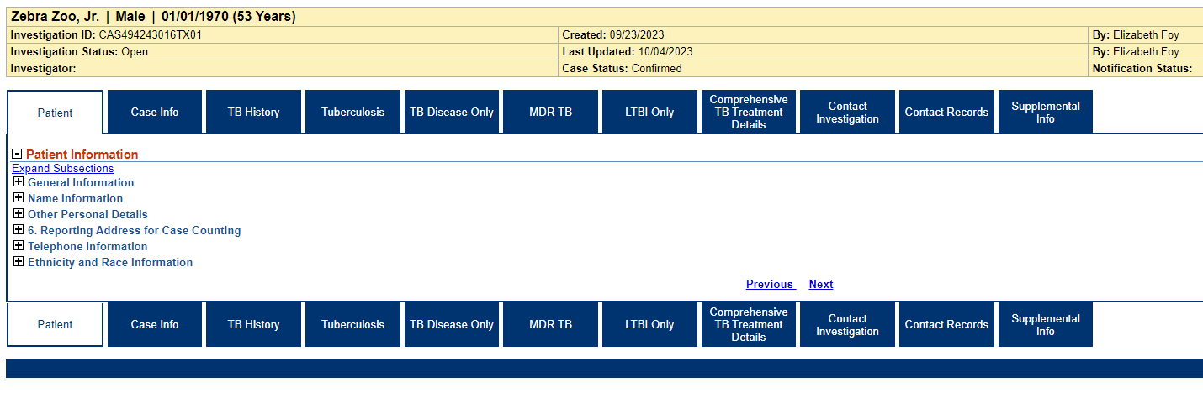

  - Name 4 data fields in the Patient tab that have pre-populated data:
Information as of date
Name Information as of Date
First Name
Last name
Reported age
Reported age in units
To name a few…

  - What must you do to enter data into the Patient tab? (Hint: what button on the top right-hand side of the screen must you click on before entering data?).

Edit
Under the Patient Information section, go into the Reporting Address for Case Counting sub-section.
There should be a date in the “Address Information As Of Date” field. Delete that date.
  - Once you delete and hit submit, what occurs? (describe or provide a screen shot).
You get a Red error message at the top that says
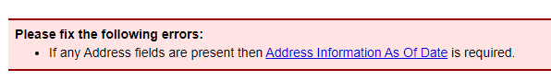
Exercise 5, the Case Info tab:
  - Using your same test case in Exercise 4, provide the name of the jurisdiction the patient has been assigned (Hint: you find this in the Investigation Information section.) _Review in training based on the name they provided in #1__.

  - What is the “Case Verification Category” result? (Hint: this is an automatic result that shows up for all patients until it is manually changed).

5- Suspected

8) In the Clinical section, under TCID Admission, what must you do to enter a “TCID Admission Date”?
You must answer “Yes” to “was Patient Admitted to TCID”, otherwise the date fields are greyed out.

Exercise 6, the TB History tab:
Under the Previous TB History section, enter the following data fields highlighted below:
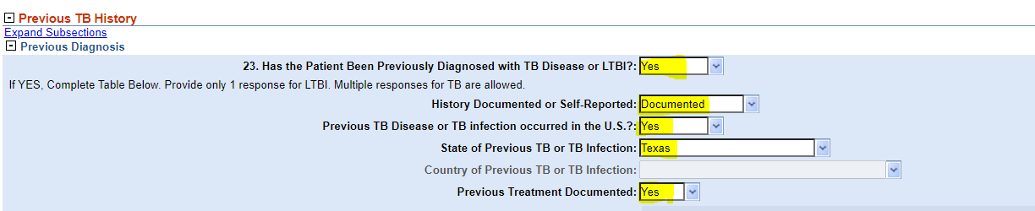

Now, in the Previous Treatment drop-down box, indicate that the patient took the following drugs: Isoniazid, Pyridoxine (Vitamin B-6), Rifapentine.

- Provide a screenshot showing all 3 drugs were successfully selected.
Screenshot should look like this:
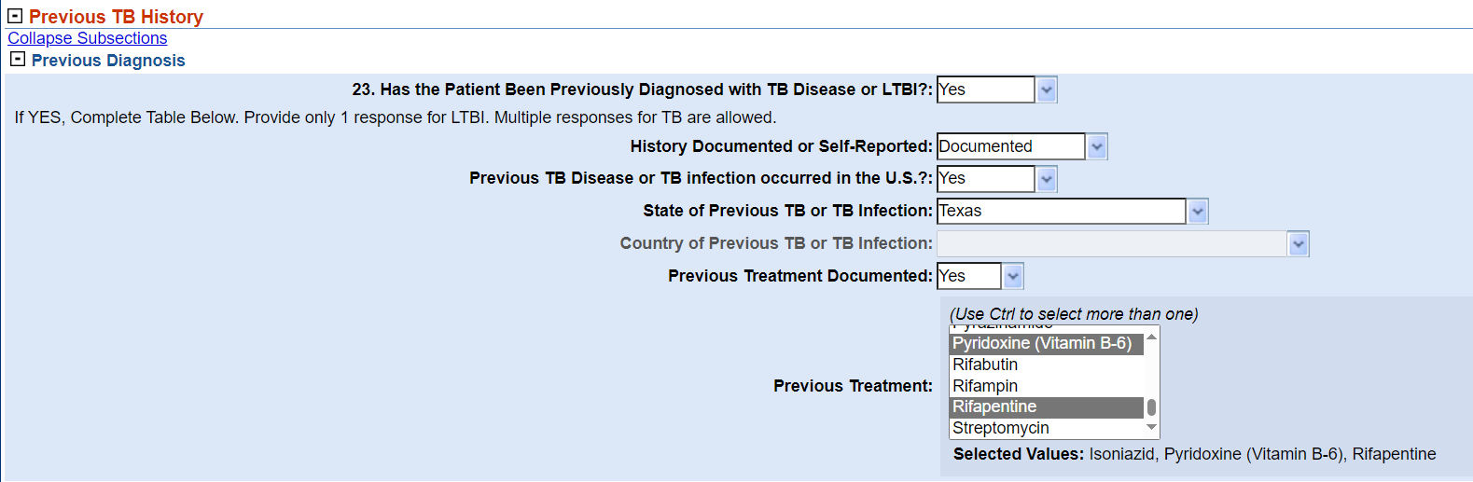

- In the Previous Positive Tests subsection, what are the drop-down options for “Results of Previous Imaging Test”?

