NEDSS Training Exercises for
Module 7: Contact Investigation Tab

Overview:
- This module contains 1 exercise, #11, with 2 parts.
- When you have finished, email your supervisor your responses.

Exercise #11 Instructions
Part 1: Contact Investigation Section of the CI Tab
Create a new or open an existing patient file on a patient with a TB (2020 RVCT) investigation.
Go into the TB investigation, and in the contact investigation tab add the following Exposure Location in the repeating block:

Exposure Location Name | Exposure Location Type | Address of Exposure Location | Start Date at This Location | End Date at This Location
Office | Office/Workplace | 201 W Howard Ln, Austin TX 78753 | 01/01/2023 | 01/15/2023

- Insert a screenshot. Review their screenshot; should look like this with the right address as 201 W Howard, and dates as per table above:
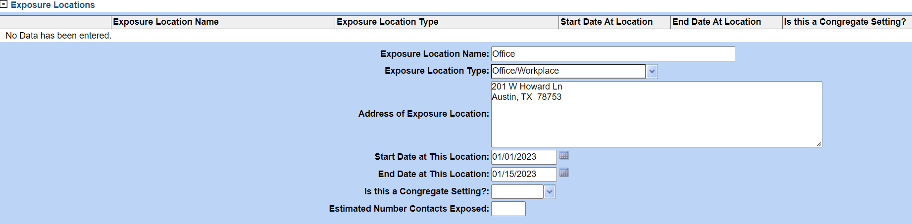

- How would you edit the “Address of Exposure Location”? Describe or provide a screenshot of button
Click inside the Address of Exposure Location box and delete what is needed and replace it with the correct information.

- Change the address to “202”. Provide a screenshot of results:
Review screenshot with new address of 202.

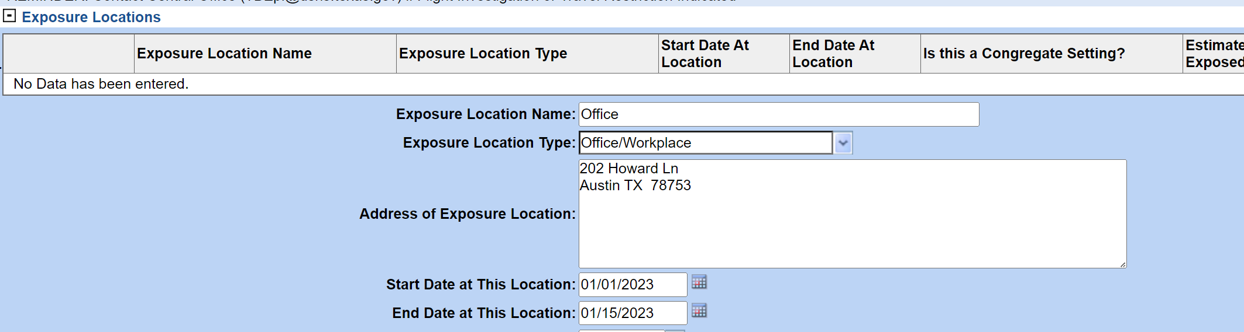

Part 2: TB Exposure Repeating Block section of the Contact Investigation Tab
The patient used in part 1 was also named as a contact in a 2018 and 2020 contact investigation.
Enter the information for both the 2018 and 2020 contact investigations.

2018 Information
Source Case State Case Number | Contact Relationship to Source Case | Date Identified as Contact | Linked Case Infection Period End Data | Contact ATS Classification
2018-TX-000012345 | Cousin | 04/04/2018 | 03/15/2018 | 1 - M. TB exposure, no evidence of infection

2020 Information
Source Case State Case Number | Contact Relationship to Source Case | Date Identified as Contact | Linked Case Infection Period End Data | Contact ATS Classification
2020-TX-000098765 | Employee | 06/05/2020 | 06/15/2020 | 1 - M. TB exposure, no evidence of infection

- Provide a screenshot in the TB Exposure Repeating Block of both the 2018 and 2020 contact investigation:
Screenshot should look like this:

