**Gen Print Plugin Installation**

(required for local registrars and AOP people who use USB signature pads)

1. Update all browsers (Internet Explorer, Chrome, Firefox, Safari) to the latest version.
2. Update Java to the latest version (version 8).
3. Go to <https://txever.dshs.texas.gov/TxEverUI/Welcome.htm> and scroll to bottom of page to download TxEVER Gen Print Plugin.
4. Install Gen Print Plugin as a **local administrator** on the computer.
5. Launch any browser and allow the connection to the Gen Print Plugin. (Select “Remember this decision” so you don’t have to repeatedly have to answer the question.
6. Scroll down to the bottom of the screen. You should see “Connection = Active”

**Troubleshooting:**

* **If it says “Connection = Waiting**” then ask customer to try other browsers to see if it says Connection = Active.
* **If all browsers say “Connection = Waiting”** then ask customer to clear cache (pronounce “cash”) for Gen Print Plugin.  
  1. Close the TxEVER website (maybe suggest closing all browsers)
  2. Find the Gen Print Plugin Icon
     + Look at the taskbar on computer where volume and battery icons usually are (usually at bottom left of screen). Right click on the Gen Print Icon (looks like a blue and white printer )
  3. Right click on the Gen Print Plugin Icon on taskbar, then select “exit.”
  4. Open windows explorer (can click on “My Computer” in the start menu)
  5. Go to the **C:** Drive folder which is sometimes called “My Computer” or “Local Disk”
  6. Click the “Users” folder
  7. Click your computer username
  8. Click the “View” menu at top of page  
     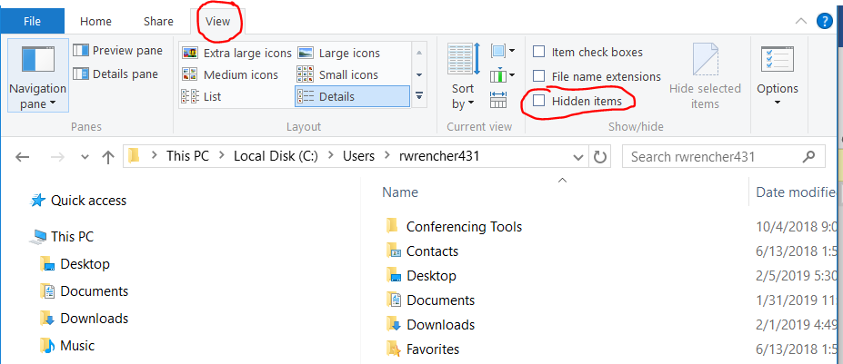
  9. Check the checkbox for “hidden items”

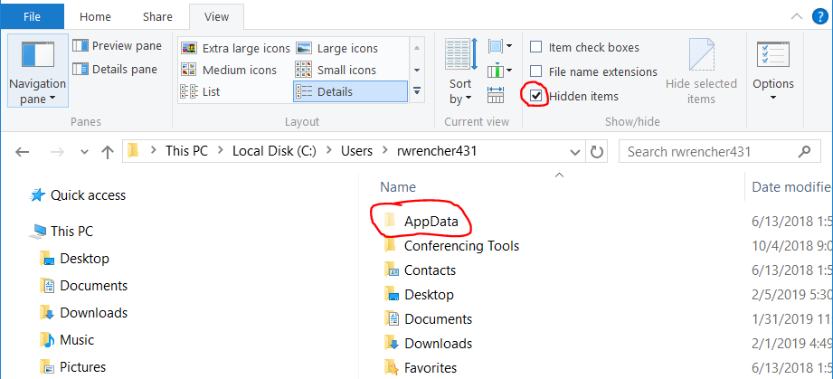

* 1. Click the “AppData” folder
  2. Click the “Roaming” folder
  3. Click the “Gen” folder
  4. Delete all the cache files (debug, allowed.dat, blocked.dat, etc)  
     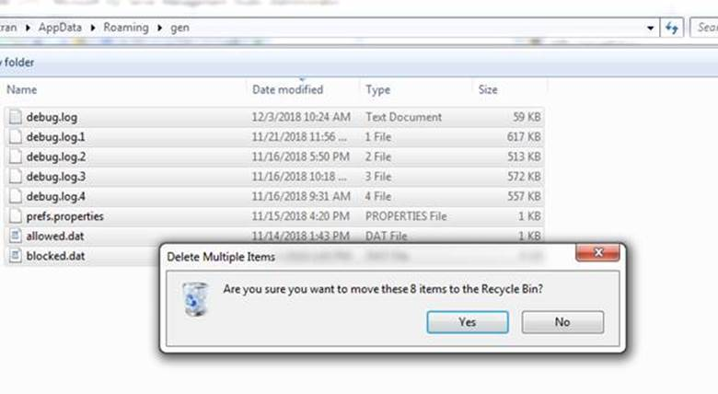
  5. Reopen Gen Print Plugin
  6. Reopen TxEVER website: <https://txever.dshs.texas.gov/TxEverUI/Welcome.htm>
     + Make sure you use HTTPS to access the secure version of TxEVER website
  7. A popup box will appear that says “Action Required to request to grant the permission to connect.” Check the “remember this decision” then select “allow”  
     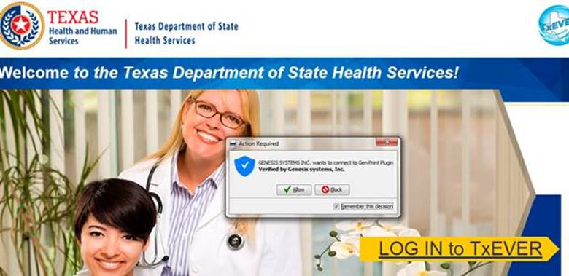
  8. You should see “Connection = Active” at the bottom of the screen now
* **If you continue to have issues after clearing Gen Print Plugin Cache,** 
  1. Make sure you have Java Version 8 downloaded to your computer.
  2. Access the full Gen Print Plugin Troubleshooting guide on the [www.dshs.texas.gov/txever](http://www.dshs.texas.gov/txever) website. A link to the document is on step 6 of the Gen Print Plugin instructions located in the FAQ and Minimum System Requirements.