Epi Curve
- Make a tool that is easily and quickly updated.
  - Don’t remake it each day.
  - Make the tool ahead of time.
    - Have time to test it.
    - Learn its strengths (exploit them)
    - Learn its weaknesses (minimize them).
  - During an incident, make updates quickly.
- Rename or make a copy of the data file with a ‘generic’ name. (“Input”, “Data”). You’ll be able to use the same name tomorrow, without feeling silly.
- Make Pivot Table
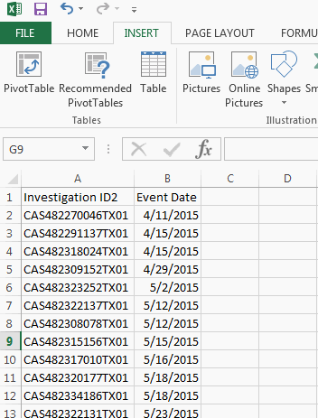

  - Use the whole columns as the Data Source
  - Put the Pivot Table on a new sheet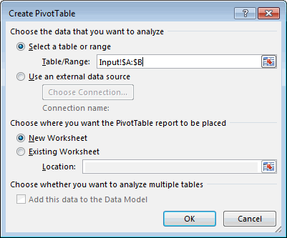
  - Date in the Row label
  - Count of Investigations in the Values
  - On the Design Tab, pull down the Grand Totals menu and select “Off for Rows and Columns”. They just get in the way.
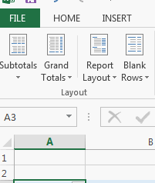
  - Rename this sheet. “Pivot”

Dates are not continuous. We can fix that.
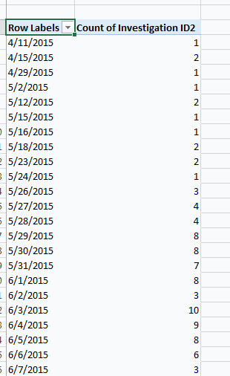

- Add a new, blank sheet. Rename as “Chart”
- Column Headers in row 1
  - Date
  - Count
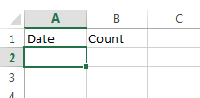

- Fill in Dates in Column A
  - Type the first date, then drag down to fill. In this case, we’re going to go all the way to row 368
    - All dates must be represented… even dates that have no cases
    - From the first date you want on your chart
    - To the last date you want on your chart.
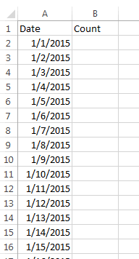
- Use VLOOKUP() function to get the counts from the Pivot Table into Column B
  - Same number of rows in Lookup Table as there are dates.
  - Use absolute references (A$4:B$368)
  - Copy all the way down to row 368.
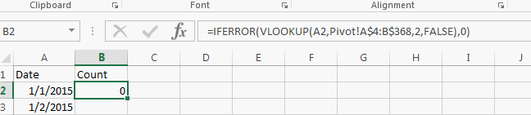
- Select columns A & B

- Insert Recommended Chart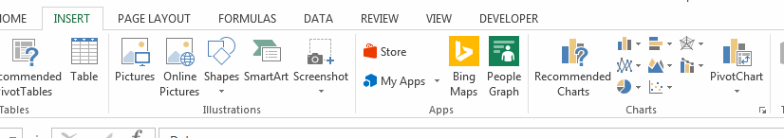

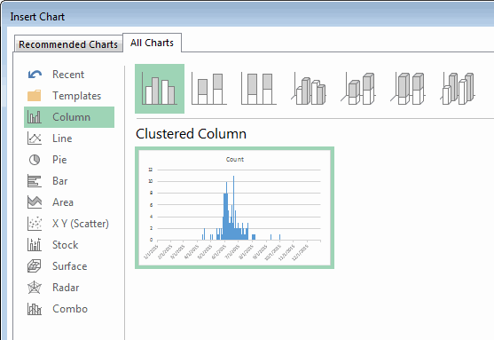
  - “All Charts”
  - Column
  - Clustered Column
  - Pick the suggestion that looks closest to what you want, then click OK.
- “Select Data”
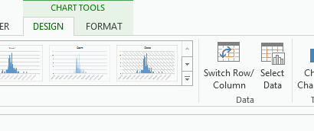
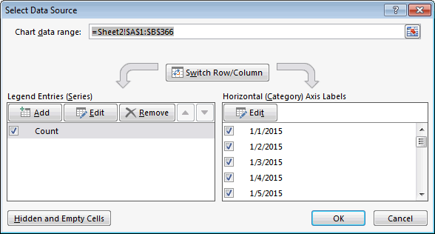
  - “Legend Entries” – Edit

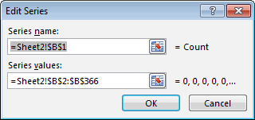
  - Make sure “Series Values” includes all cells in the data

  - “Horizontal Axis Labels” – Edit

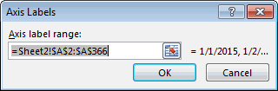
  - Make sure “Axis label range” includes all of the row labels

- Format Columns

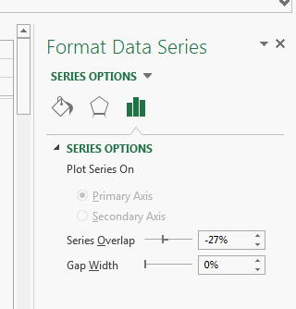
  - Double-Click on a column in the chart
  - Change Gap Width to 0%

- Add a Trend Line
  - Click in the Chart Area
  - Click on the plus sign to the right
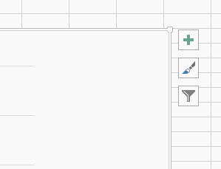
  - Click the checkbox labeled Legend
  - Do NOT click the check box. Click on arrow next to Trend Lines
  - Scroll down and click on More Options

  - Click on Paint icon
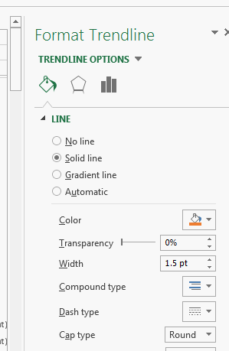
  - Select a contrasting color
  - Select the solid line on the Dash type control
  - Click on Chart icon
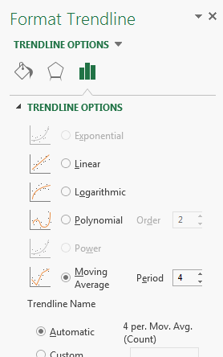
  - Select radio button next to Moving Average
  - Set the Period to the number of days that give a good picture of the rise and fall of events.
- On the Format Tab, select “Text Box” 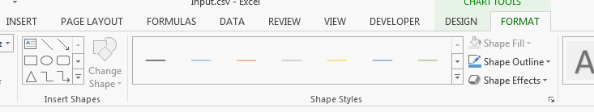
  - Click and drag in the Chart Area to insert
  - Type message
  - Change “Line” to “Solid Line”
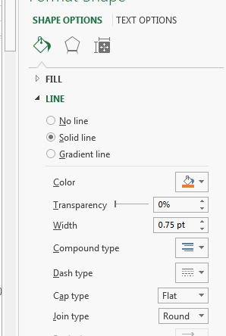
- Select the arrow from the Shapes menu
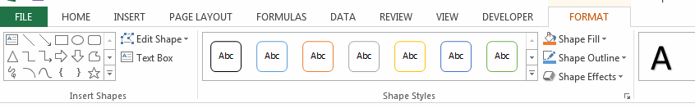
  - Click and drag to add the arrow.
  - Set the color of the Arrow
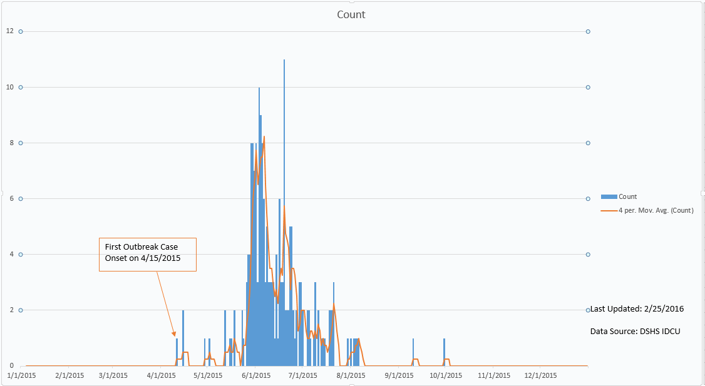
- All Charts, graphs, maps and tables that will be published should include:
  - Data Source
  - Creator name
  - Date of last update
  - Department name/logo
- Save to an Excel format.
  - Use a generic name. You *might* want to include a version date. You might not.

The next day….
- Get the new data
- Open the new data file and the old Epi Curve file.
- Copy the new data
- Paste into the “Input” or “Data” tab of the Epi Curve file, replacing the old data.
- Select the “Pivot” worksheet
- On the “Analyze” tab, click “Refresh”
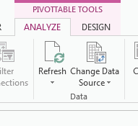
- Select the “Chart” worksheet
- Change the Last Updated note, and any other annotations.
